Introduction to Digital Logic

EECS/CSE 31L

**Assignment 1: 1-Bit Full Adder/Subtractor**

Prepared by: Jack Melcher

Student ID: 67574625

EECS Department

Henry Samueli School of Engineering

University of California, Irvine

January 14, 2015

**1 Block Description**

Take in two 1-bit inputs and perform addition or subtraction

**2 Input/Output Port Description**

|  |  |  |  |
| --- | --- | --- | --- |
| Port name | Port size | Port Type | Description |
| Input0 | 1 | IN | Value of first input |
| Input1 | 1 | IN | Value of second input |
| CarryIn | 1 | IN | Carry in value |
| AddORSub | 1 | IN | Determine which operation to perform |
| Sum | 1 | IN | The operation result |
| CarryOut | 1 | IN | The carry out value |

**3 Design Schematics**

**Truth Tables:**

Original Full Adder

|  |  |  |  |  |
| --- | --- | --- | --- | --- |
| In_0 | In_1 | Cin | Cout | Sum |
| 0 | 0 | 0 | 0 | 0 |
| 0 | 0 | 1 | 0 | 1 |
| 0 | 1 | 0 | 0 | 1 |
| 0 | 1 | 1 | 1 | 0 |
| 1 | 0 | 0 | 0 | 1 |
| 1 | 0 | 1 | 1 | 0 |
| 1 | 1 | 0 | 1 | 0 |
| 1 | 1 | 1 | 1 | 1 |

Two’s Complement Adder/Subtractor

|  |  |  |
| --- | --- | --- |
| AddOrSub | Function | Operation |
| 0 | In_0 + In_1 | Addition |
| 1 | In_0 + In_1’ + 1 | Subtraction |

In_1 XOR AddOrSub

|  |  |  |
| --- | --- | --- |
| In_1 | AddOrSub |  |
| 0 | 0 | 0 |
| 0 | 1 | 1 |
| 1 | 0 | 1 |
| 1 | 1 | 0 |

Full Adder/Subtractor

|  |  |  |  |  |
| --- | --- | --- | --- | --- |
| In_0 | In_1 | Cin | Cout | Sum |
| 0 | 0 | 0 | 0 | 0 |
| 0 | 1 | 0 | 0 | 1 |
| 1 | 0 | 0 | 0 | 1 |
| 1 | 1 | 0 | 1 | 0 |
| 0 | 0 | 1 | 1 | 0 |
| 0 | 1 | 1 | 0 | 1 |
| 1 | 0 | 1 | 1 | 1 |
| 1 | 1 | 1 | 1 | 0 |

**Boolean Expressions:**

In_1 = In_1 ⊕ AddOrSub

Cin = AddOrSub

Sum = (In_0’)(In_1’)(Cin) + (In_0’)(In_1)(Cin’) + (In_0)(In_1’)(Cin’) + (In_0)(In_1)(Cin)

Cout = (In_0’)(In_1)(Cin) + (In_0)(In_1’)(Cin) + (In_0)(In_1)(Cin’) + (In_0)(In_1)(Cin)

In_1 = In_1 ⊕ AddOrSub

Cin = AddOrSub

Sum = (In_0 ⊕ In_1) ⊕ Cin

Cout = (In_0)(In_1) + (Cin)(In_0 ⊕ In_1)

Sum = (In_0 ⊕ (In_1 ⊕ AddOrSub)) ⊕ Cin

Cout = (In_0)(In_1 ⊕ AddOrSub) + ((Cin)(In_0 (In_1 ⊕ AddOrSub)))

**Gate Representation:**



**4 Compilation**

AddSub compiled

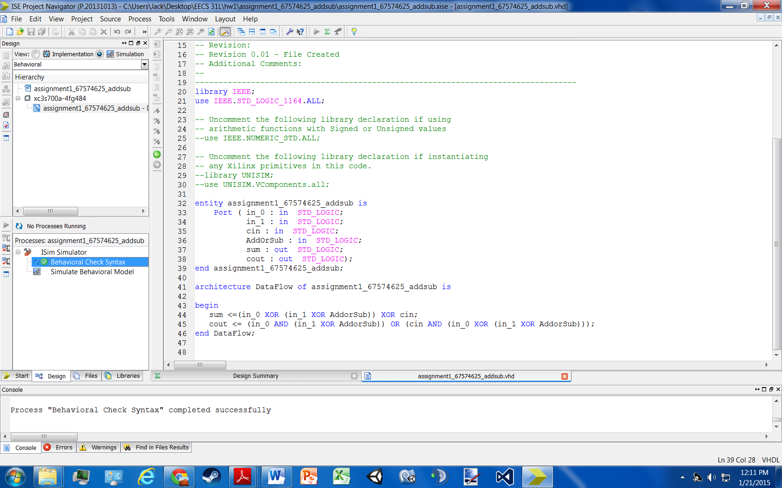

Testbench compiled

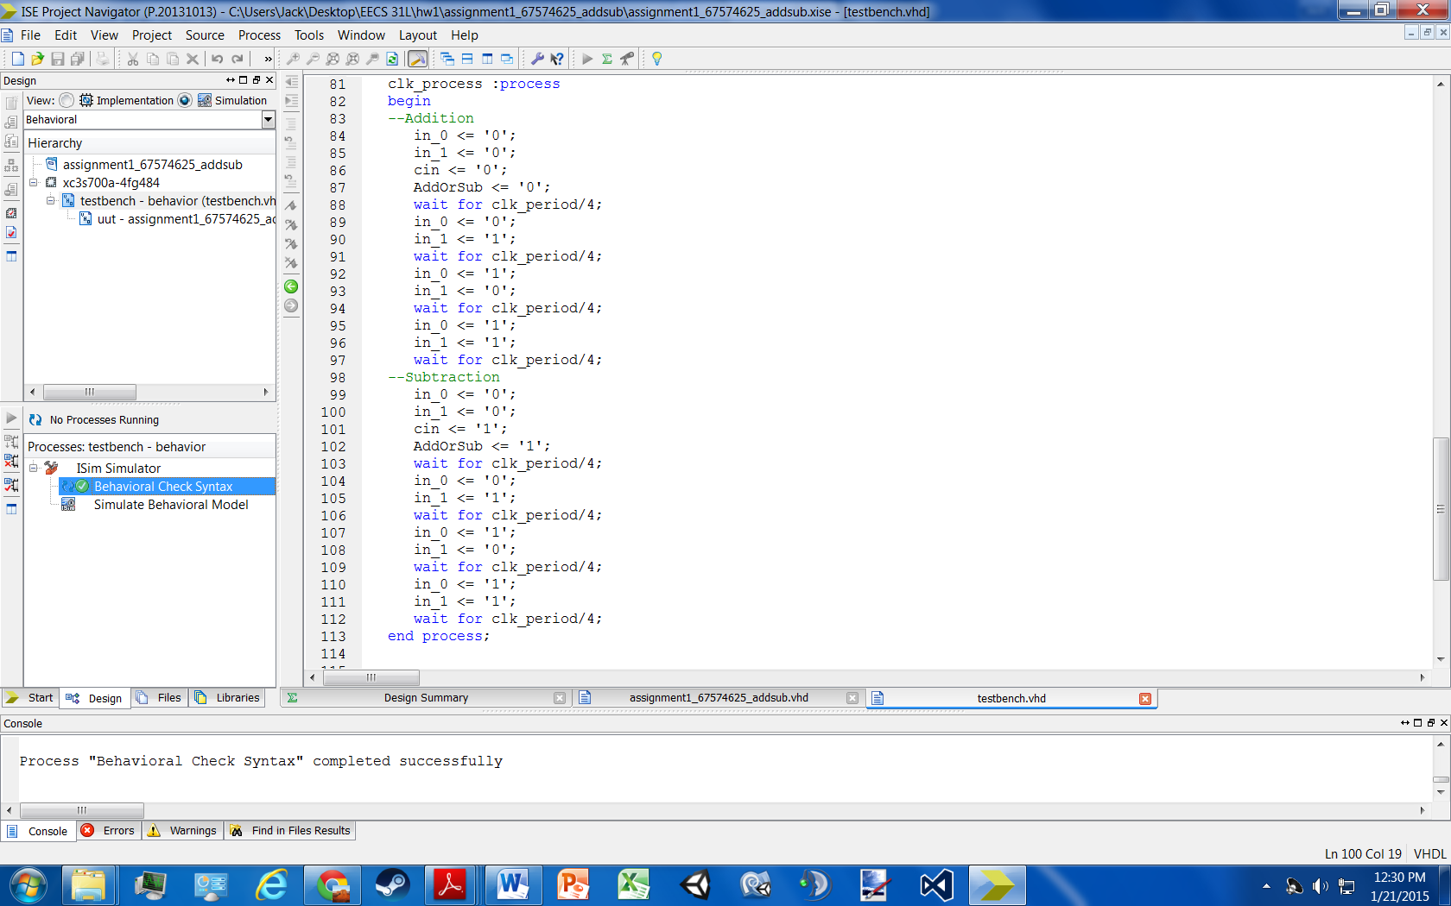

**5 Elaboration**

**Assumptions:**

* in_0, in_1, cin, AddorSub, sum, and cout are all 1-Bit
* cin and Add or Sub are essentially same and are given the same value. If cin = ‘0’, then AddorSub = ‘0’. If cin = ‘1’, then AddorSub = ‘1’.

**Errors:**

* I tried making an input variable behave like an output variable
* I resolved it by inserting that equation into the output equations

**Simulation Log:**

Started : "Simulate Behavioral Model".

Determining files marked for global include in the design...

Running fuse...

Command Line: fuse -intstyle ise -incremental -o {C:/Users/Jack/Desktop/EECS 31L/hw1/assignment1_67574625_addsub/testbench_isim_beh.exe} -prj {C:/Users/Jack/Desktop/EECS 31L/hw1/assignment1_67574625_addsub/testbench_beh.prj} work.testbench {}

Running: C:\Xilinx\14.7\ISE_DS\ISE\bin\nt64\unwrapped\fuse.exe -intstyle ise -incremental -o C:/Users/Jack/Desktop/EECS 31L/hw1/assignment1_67574625_addsub/testbench_isim_beh.exe -prj C:/Users/Jack/Desktop/EECS 31L/hw1/assignment1_67574625_addsub/testbench_beh.prj work.testbench

ISim P.20131013 (signature 0x7708f090)

Number of CPUs detected in this system: 4

Turning on mult-threading, number of parallel sub-compilation jobs: 8

Determining compilation order of HDL files

Parsing VHDL file "C:/Users/Jack/Desktop/EECS 31L/hw1/assignment1_67574625_addsub/assignment1_67574625_addsub.vhd" into library work

Parsing VHDL file "C:/Users/Jack/Desktop/EECS 31L/hw1/assignment1_67574625_addsub/testbench.vhd" into library work

Starting static elaboration

Completed static elaboration

Compiling package standard

Compiling package std_logic_1164

Compiling architecture dataflow of entity assignment1_67574625_addsub [assignment1_67574625_addsub_defa...]

Compiling architecture behavior of entity testbench

Time Resolution for simulation is 1ps.

Waiting for 1 sub-compilation(s) to finish...

Compiled 5 VHDL Units

Built simulation executable C:/Users/Jack/Desktop/EECS 31L/hw1/assignment1_67574625_addsub/testbench_isim_beh.exe

Fuse Memory Usage: 29836 KB

Fuse CPU Usage: 389 ms

Launching ISim simulation engine GUI...

"C:/Users/Jack/Desktop/EECS 31L/hw1/assignment1_67574625_addsub/testbench_isim_beh.exe" -intstyle ise -gui -tclbatch isim.cmd -wdb "C:/Users/Jack/Desktop/EECS 31L/hw1/assignment1_67574625_addsub/testbench_isim_beh.wdb"

ISim simulation engine GUI launched successfully

Process "Simulate Behavioral Model" completed successfully

**6 Waveform**

